Welcome to VCC Online Learning!
Thank-you for participating in [enter your course or program name here] at Vancouver Community College. By now you should have received a registration document stating your Student ID# and course date information. If not, please contact and follow the prompts.
Please follow the information provided below carefully. If you require technical support for login issues please refer to the support information at the end of this document.
Course begins: The start date is noted on your registration document (as noted above).
Must be completed by: The end date is noted on your registration form (midnight on that day).
You must login by*: [enter the login deadline or first day of the course here].
*Note: If you have not logged-in by midnight of the date noted above you may be withdrawn from the course.

For First Time Access to Your Online Course |  | Step 5. Locate your course in one of the following ways:  Option A: If you have been pre-enrolled in your course, you will find your course under the “My Courses” heading and you can just click on the course name. Your course is called:  [ enter the course LONG name here]  Option B: If you have not been pre-enrolled in your course, use the “Search Courses” box, located at the bottom center of the screen, to search for your course name or number (e.g., TESO 1234) or follow the Course Category links to locate your course under your Centre or School.  Step 6. When prompted, enter the following  enrolment key: [ copy the enrolment key and paste here]  Step 7. Proceed to the step-by-step instructions in your course homepage to begin your course.
Step 1. Access the myVCC website: http://my.vcc.ca

Step 2. Enter your full Student ID, including the leading zeros (example, 000123456) and your password and then select [Submit].
Password: for first-time users, the default password is your birth date in MMDDYY format.

Step 3. To access Moodle (VCC’s online Learning Management System), click on the “Online Courses” tile
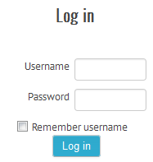
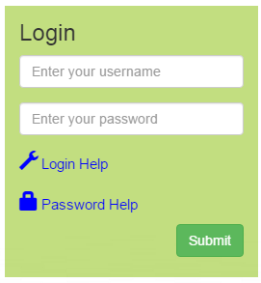
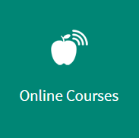
Step 4. Again, enter your Username and Password (exactly the same as the ID and password you just used in step 2), and click on the Login button.
 |  | For Regular Access to Your Online Courses
 |  | Follow steps 1-5
 |  | For Technical Assistance
For problems with steps 1 to 3, contact the VCC Helpdesk by email at helpdesk@vcc.ca. They will respond within one business day.

For any problems experienced with steps 4 to 6, or within Moodle please contact your instructor at:
[enter instructor phone and/or email here].

